Access time comparisons for lists, stacks, and queues:

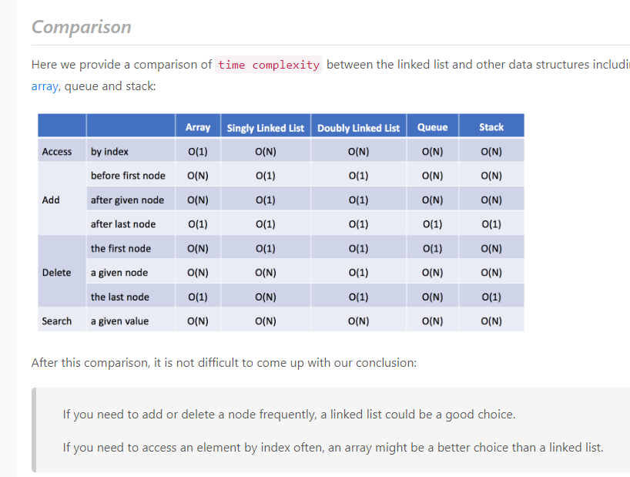

***Some general concepts to review***

1. Depth first search (and transforming things that don’t look like a tree into a tree, then doing depth first search)
2. Breadth first search
   1. A
3. Stacks
   1. Parentheses/bracket problem
4. Hash tables
   1. In general, but also how to use them alongside other algos, like if you have to keep track of values during a search, or as you iterate through a list
5. Fibonacci
   1. Implement 3 different ways (standard loop, recursive, dynamic)
6. Variable/pointer manipulation
   1. Leading/laggard, front-to-back and back-to-front
   2. This is more like a codding thing
   3. Palindrome is a good example. Longest string in a substring that is a palindrome
7. Reversing a linked list
   1. Duplicates, removing duplicates
8. Sorting fundamentals (quicksort, mergesort, bubblesort. Runtime and space complexity
9. Recursion
10. Custom data structures (oop)
11. Binary search